**Shifts in demand**

The position of the demand curve will shift to the left or right following a change in an underlying determinant of demand.

Increases in demand are shown by a shift to the right in the demand curve. This could be caused by a number of factors, including a rise in income, a rise in the price of a substitute or a fall in the price of a complement.

**Demand schedule**

A shift in demand to the right means an increase in the quantity demanded at every price. For example, if drinking cola becomes more fashionable demand will increase at every price.

|  |  |  |
| --- | --- | --- |
| **PRICE (£)** | **ORIGINAL Qd** | **NEW Qd** |
| 1.10 | 0 | 100 |
| 1.00 | 100 | 200 |
| 90 | 200 | 300 |
| 80 | 300 | 400 |
| 70 | 400 | 500 |
| 60 | 500 | 600 |
| 50 | 600 | 700 |
| 40 | 700 | 800 |
| 30 | 800 | 900 |

**Increases in demand**

An *increase* in demand can be illustrated by a shift in the demand curve to the right.

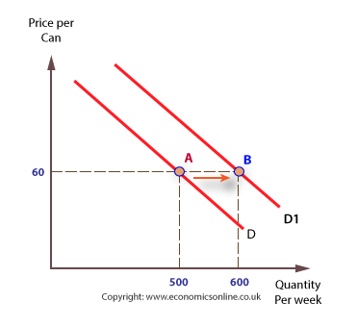

**Decreases in demand**

Conversely, demand can decrease and cause a shift to the left of the demand curve for a number of reasons, including a fall in income, assuming a good is a normal good, a fall in the price of a substitute and a rise in the price of a complement.

**Demand schedule**

For example, if the price of a substitute, such as fizzy orange, *falls*, then *less* cola is demanded at each price, as consumers switch to the substitute.

|  |  |  |
| --- | --- | --- |
| **PRICE (£)** | **ORIGINAL Qd** | **NEW Qd** |
| 1.10 | 0 |  |
| 1.00 | 100 |  |
| 90 | 200 | 100 |
| 80 | 300 | 200 |
| 70 | 400 | 300 |
| 60 | 500 | 400 |
| 50 | 600 | 500 |
| 40 | 700 | 600 |
| 30 | 800 | 700 |

Decreases in demand are shown by a shift of the demand curve to the left.

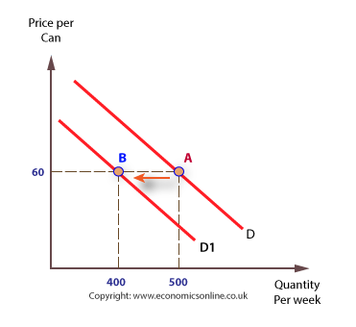

**Definition:** A shift in the demand curve is when a [determinant of demand](https://www.thebalance.com/five-determinants-of-demand-with-examples-and-formula-3305706) *other than price*changes. Here are these other four determinants.

1. [Income](https://www.thebalance.com/what-is-average-income-in-usa-family-household-history-3306189) of the buyers.
2. [Consumer trends](https://www.thebalance.com/consumer-spending-trends-and-current-statistics-3305916) and tastes.
3. Expectations of future price, supply, needs, etc.
4. The price of related goods. These can be substitutes, such as beef vs. chicken. They can also be complementary, such as beef and Worcestershire sauce.

There is a fifth determinant that applies to [aggregate demand](https://www.thebalance.com/aggregate-demand-definition-formula-components-3305703) only.

That is the number of potential buyers.

The [demand curve](https://www.thebalance.com/demand-curve-definition-types-and-how-it-works-3305705) plots the relationship between the quantity [demanded](https://www.thebalance.com/what-is-demand-definition-explanation-effect-3305708) of a good or service and its price. The curve depicts in a graphical way the [demand schedule](https://www.thebalance.com/demand-schedule-definition-and-real-life-example-3305719), which details exactly how many units will be bought at each price. The [law of demand](https://www.thebalance.com/law-of-demand-definition-explained-examples-3305707) guides that amount. That says less is bought at a higher price [*ceteris paribus*](https://www.thebalance.com/ceteris-paribus-definition-pronunciation-and-examples-3305723)*.*That means all determinants of demand other than price must stay the same.

**SUPPLY**

## Shifts in supply

The position of a supply curve will change following a change in one or more of the underlying determinants of supply. For example, a change in [costs](http://www.economicsonline.co.uk/Business_economics/Costs.html), such as a change in labour or raw material costs, will shift the position of the supply curve.

### Rising costs

If costs rise, less can be produced at any given price, and the supply curve will shift to the left.

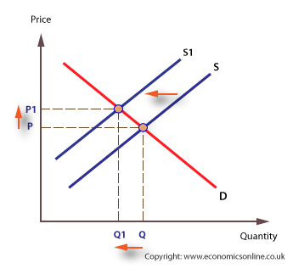

### Falling costs

If costs fall, more can be produced, and the supply curve will shift to the right.

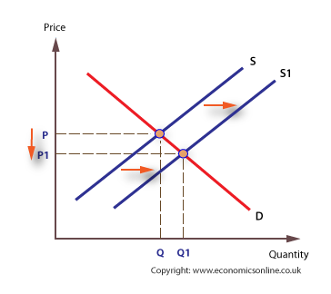

Any change in an underlying determinant of supply, such as a change in the availability of factors, or changes in weather, taxes, and subsidies, will shift the supply curve to the left or right.